MINISTRY OF GENERAL EDUCATION
I/SCIENCE LESSON PLAN
NAME OF TEACHER:________________________ SCHOOL:_____________________
GRADE | TOPIC | SUB TOPIC | DURATION | DATE
8 | REFLECTION AND REFRACTION OF LIGHT | REFLECTION | ____min | ____/___/__
ATTENDANCE: Boys:______ Girls:_______ Total:_____
TEACHING/ LEARNING AIDS : Lab Apparatus, Chalk board, Learners books and Charts.
REFERENCES : I/Science Progress book 8, I/Science Study kits 2018.
RATIONALE: This is lesson number one on Reflection and Refraction of light. It will help learners acquire skills and values of how to determine the types of heat transfer. Group work, discussion, demonstration and Question & Answer methods will be used to execute the lesson.
PRE-REQUISITE SKILLS/ KNOWLEDGE: learners have prior knowledge on light.
SPECIFIC OUTCOMES, LSBAT:
- Define the term Reflection
- Investigate the characteristics of reflection of light in a mirror.
- Carry out experiments on Reflection
STAGE | CONTENT | TEACHERS ACTIVITY | PUPILS ACTIVITY | METHODS
INTRODUCTION  ____min | Reflection  - Reflection is the bouncing of light off a smooth surface.  - Light that bounces off a smooth surface such as a mirror is reflected in a regular way while light bouncing off a rough surface is reflected in an irregular way. | Teacher asks random questions during the introduction | Pupils respond and participate | Brainstorm
D  E  V  E  L  O  P  M  E  N  T  ___min | Practical Activity  The figures below illustrate regular (smooth) reflection and irregular (diffused) reflection.  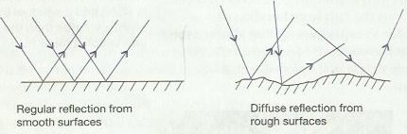  The characteristics of reflection of light in a mirror.  This can be done by carrying out an experiment as follows:  - Place the plain paper on the cardboard and fix it at the edges using paper clips.  - Draw a horizontal line on a sheet of plain paper and then draw a perpendicular line to the horizontal line. This is the normal.  - Measure a 300 angle to the perpendicular line and draw the line AB.  - Place a plain mirror upright on the horizontal line with the reflecting surface facing the normal.  - Fix three drawing pins P.Q and R on the line AB representing the incident ray. Look into the mirror and find the images P, Q and R.  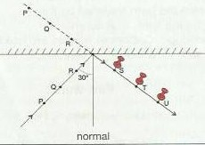  - Fix pins S, T and U to the paper in line with the image P, Q and R, as shown in figure below.  - Measure the angles formed that represent the angle of incidence and the  - angle of reflection.  - Repeat the experiment using different angles.  Observation  The angle of incidence and the angle of reflection are always equal, no matter what the size of the angle of incidence is.  Conclusion  When light is reflected, the angle of incidence is always equal to the angle of reflection. | Teacher explains the details to the learners  Teacher puts pupils in groups to discuss  Teacher writes brief notes on the board | Pupils listen and ask questions  Learners discuss and bring out main points  Pupils copy the notes in their books | Teachers  Exposition  Group  work  Individual  Work
EXPERIMENT
- Define the term Reflection and Investigate the characteristics of reflection of light in a mirror Demonstrate.
TEACHER/ PUPILS EVALUATION ....................................................................................

